**FAMILY WEALTH INDEX STIMULI**

|  |  |  |
| --- | --- | --- |
| **River or stream** | **Well or borehole** | **Communal tap** |
| **Tap in the home** |  | Image result for picture of a protected spring  **A protected Spring**  **Tap in the home** |

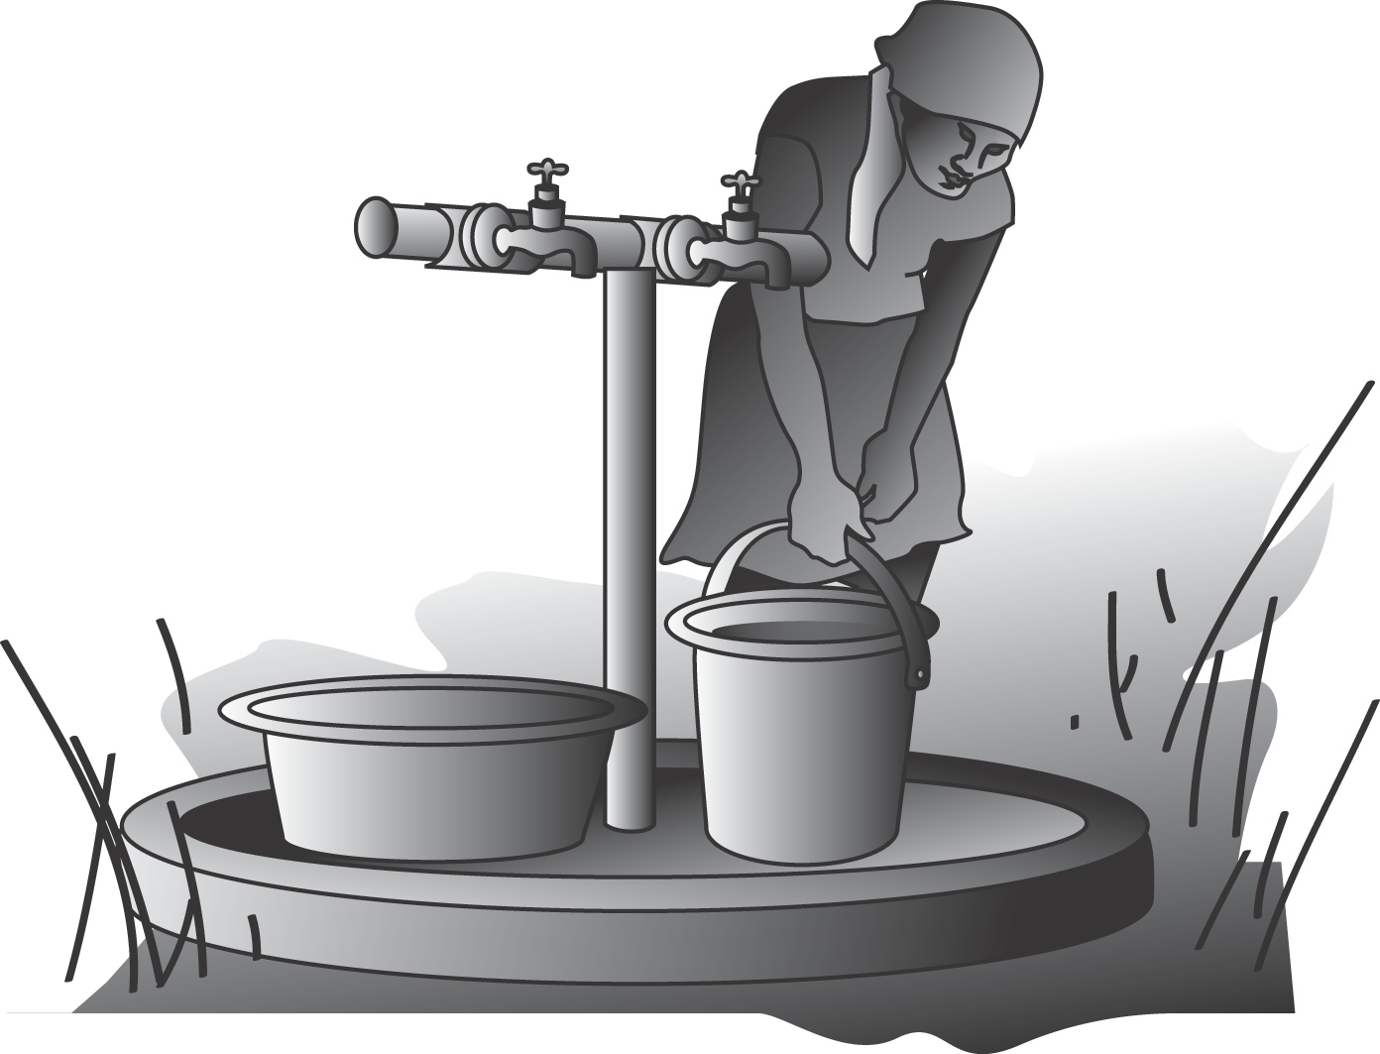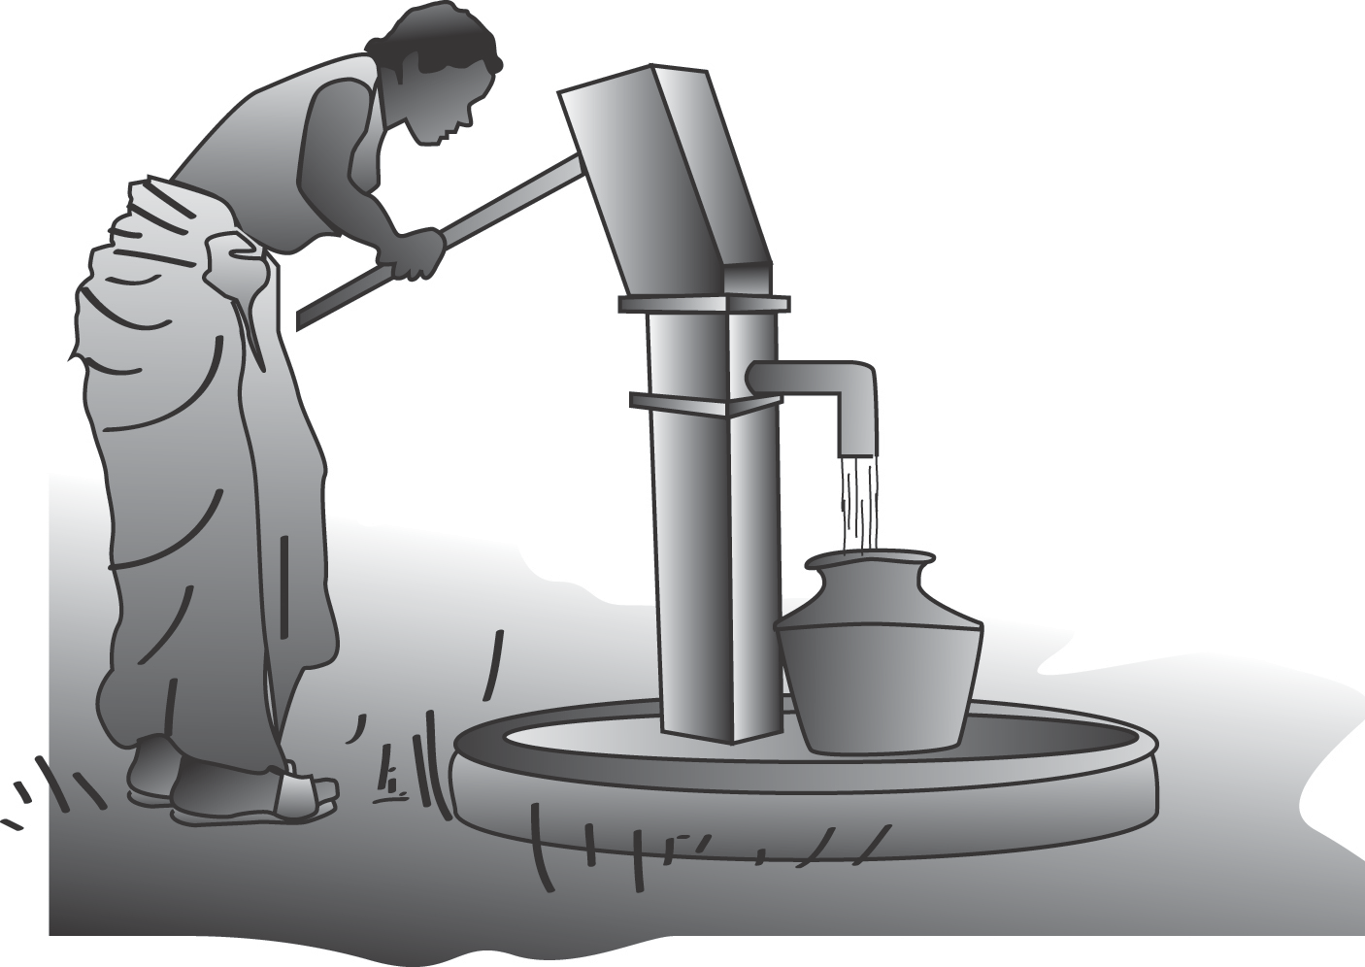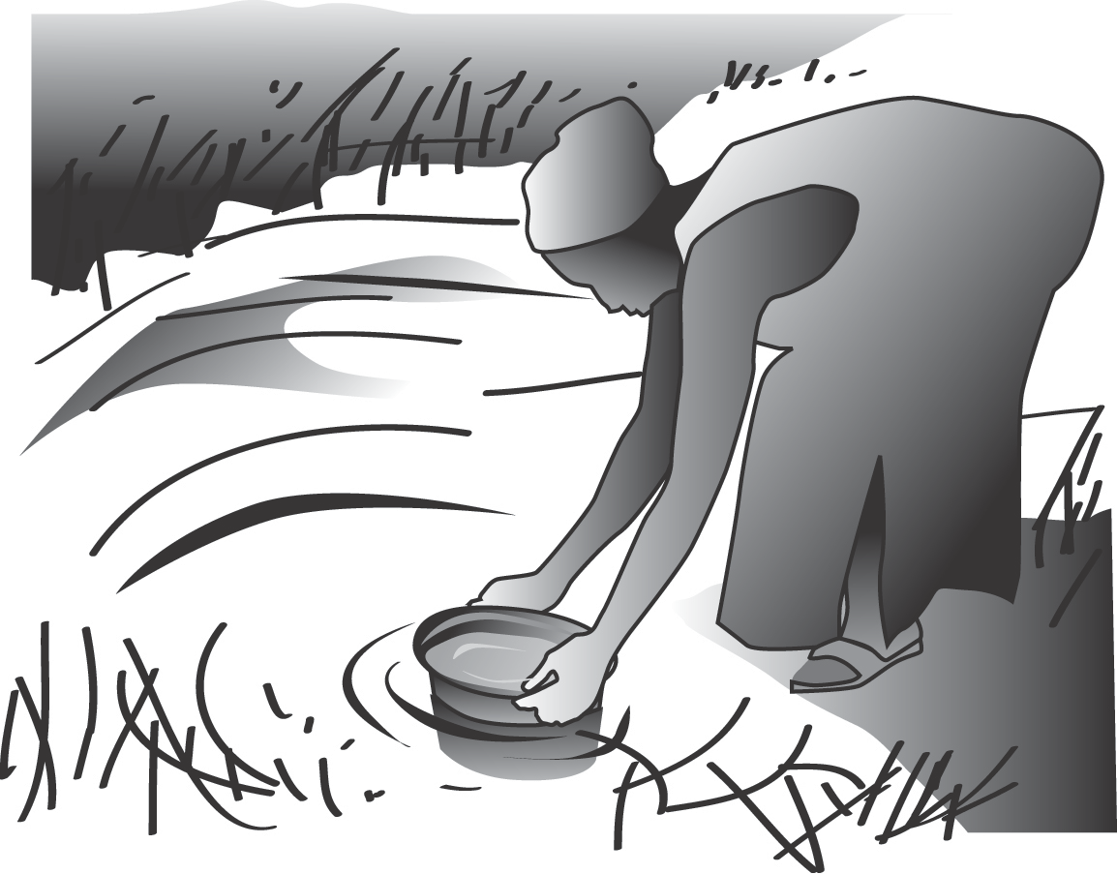  
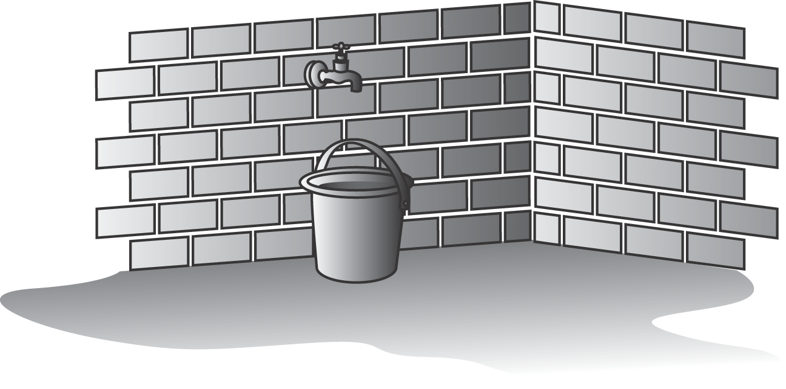Question 21

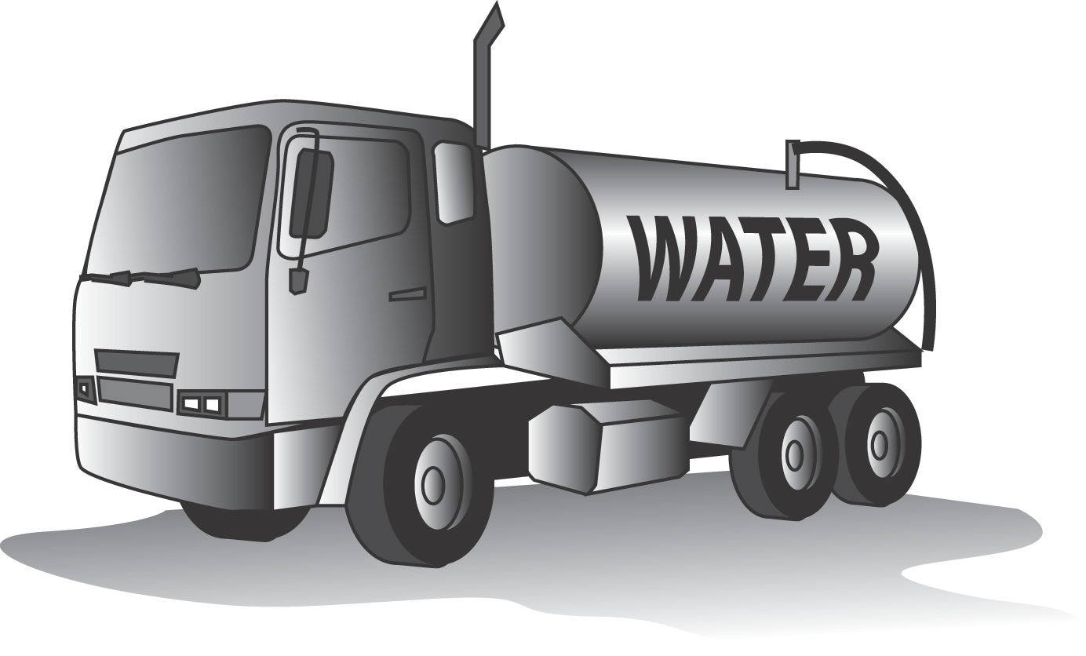 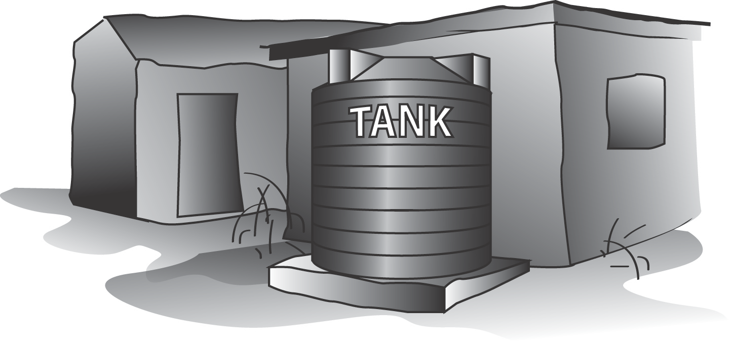

Water truck Water Tanker

Question 21b

Outside the house In a shed

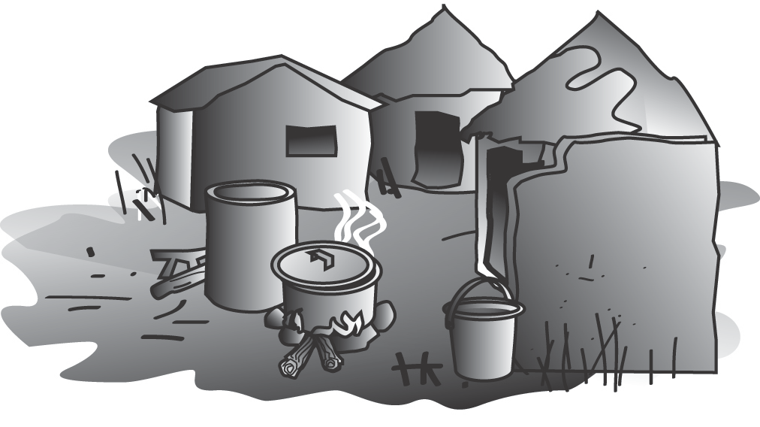 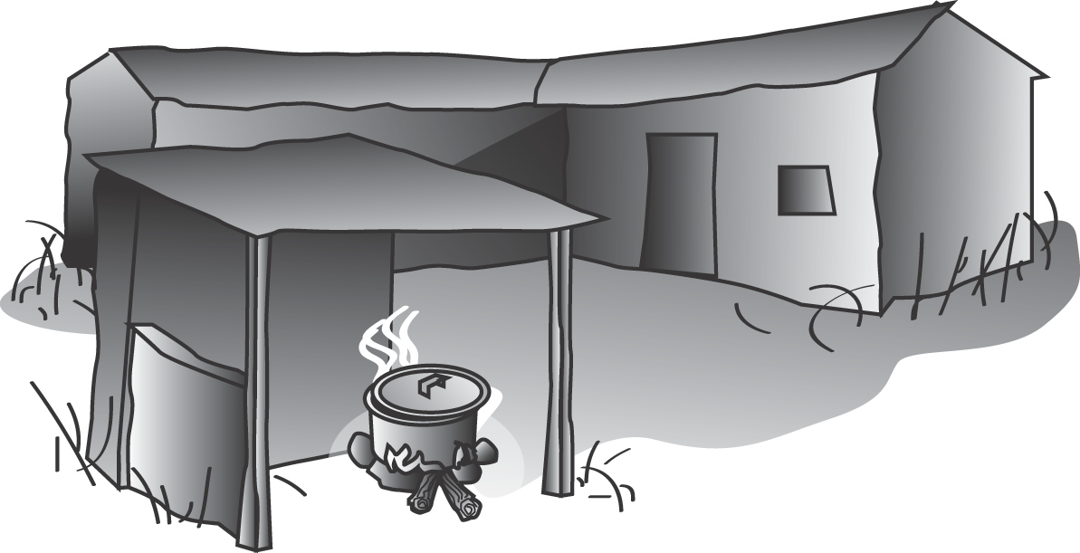

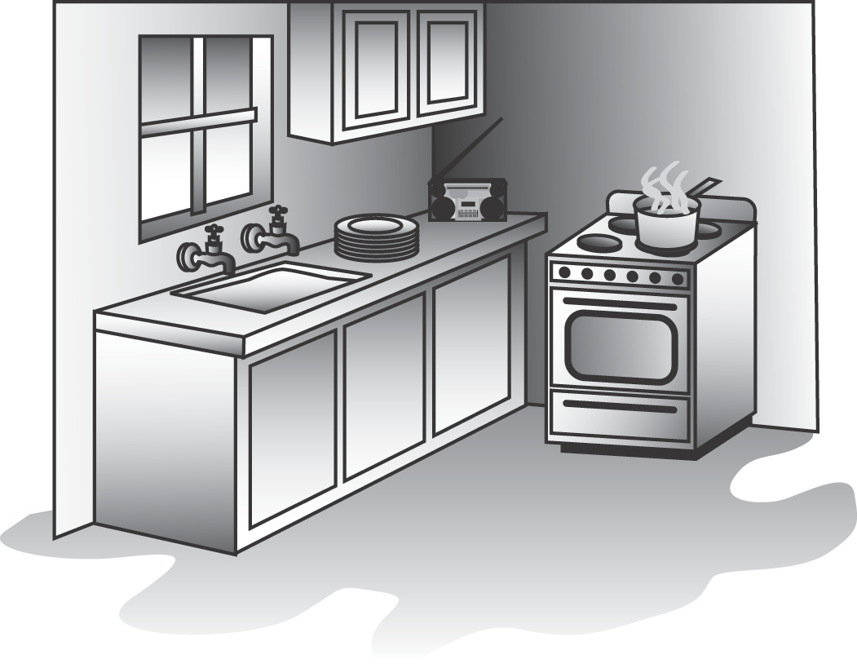

**Question 26**

Inside the house

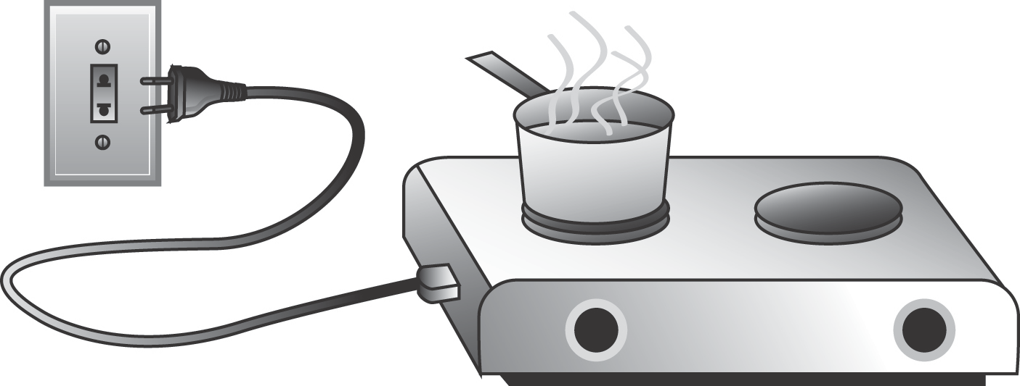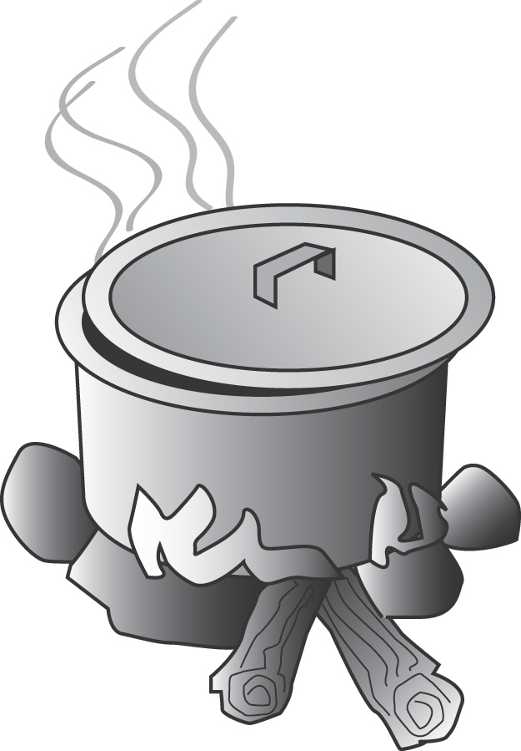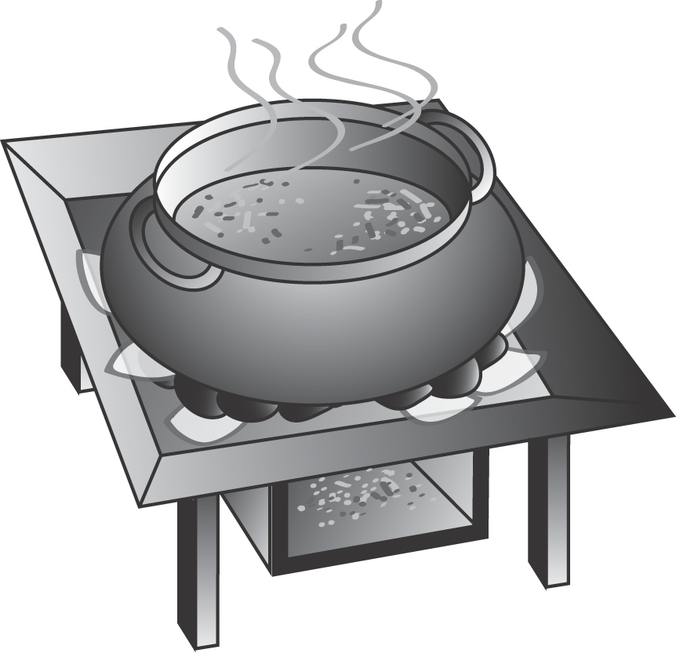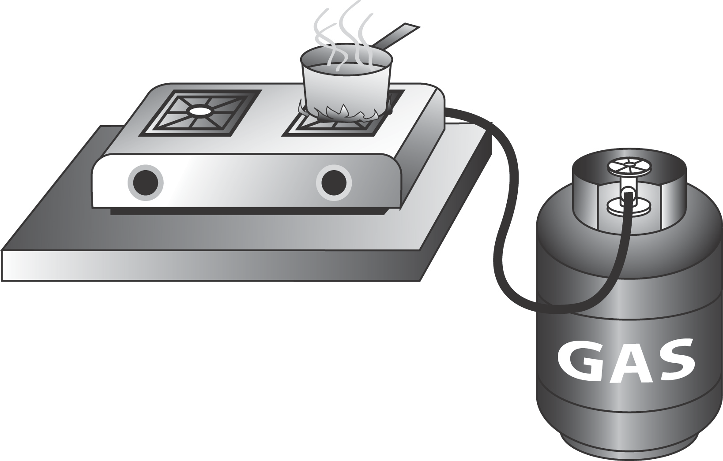

|  |  |  |
| --- | --- | --- |
| **Using firewood** | **Using a coal pot** | **Using a stove - gas** |
| **Using a stove - electricity** | **Using a cooker** | http://previews.123rf.com/images/itman47/itman471312/itman47131200092/24407226-Thai-Style-Cooking-with-Charcoal-Stove--Stock-Photo.jpg  **Using a charcoal Stove** |

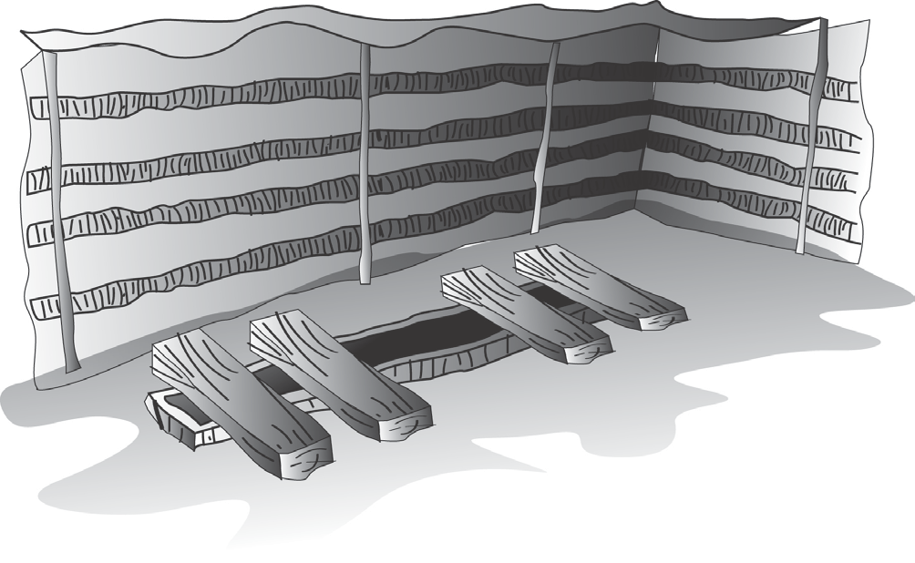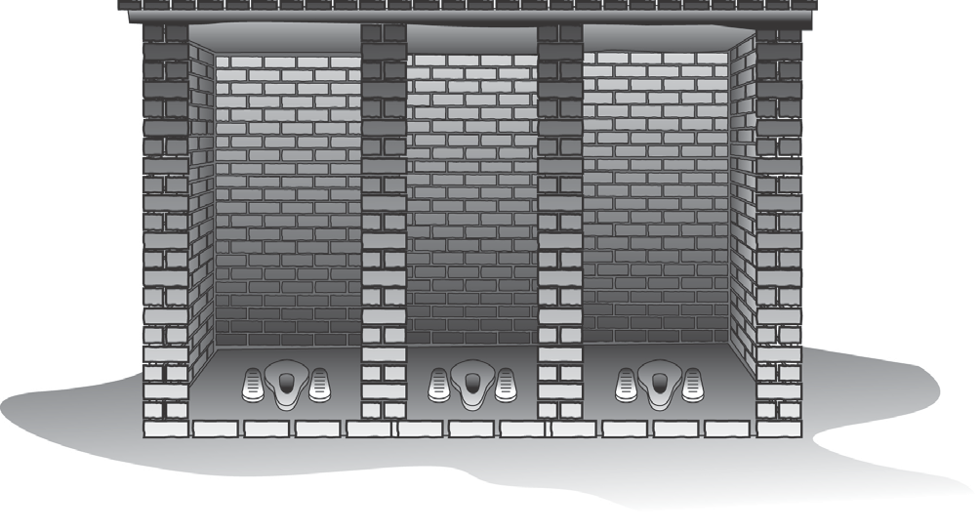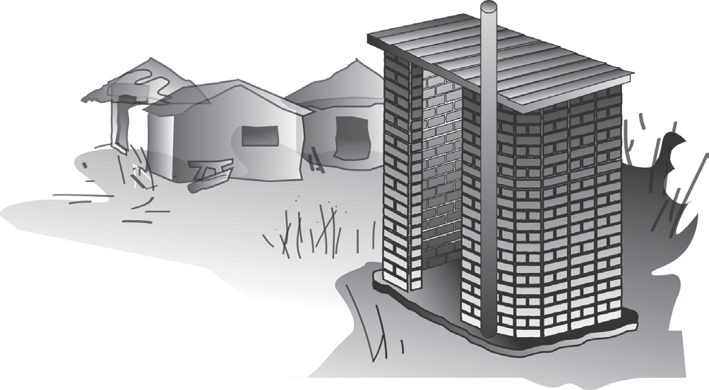

|  |  |  |
| --- | --- | --- |
| **A pit toilet** | **A shared toilet** | **A communal toilet** |
| **A flush toilet outside your house** |  | **A flush toilet inside your house** |

Radio Mobile phone Television

  

 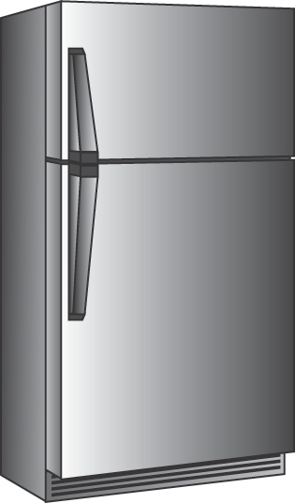

Computer Refrigerator

**Question 22, 23, 27, 28, 29**

Bicycle Car/truck

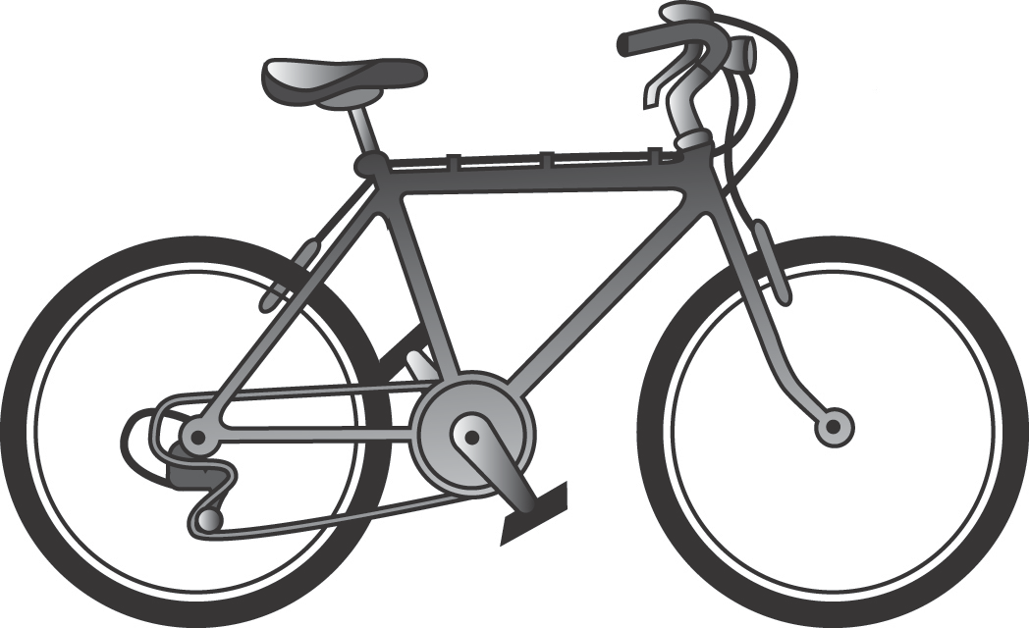 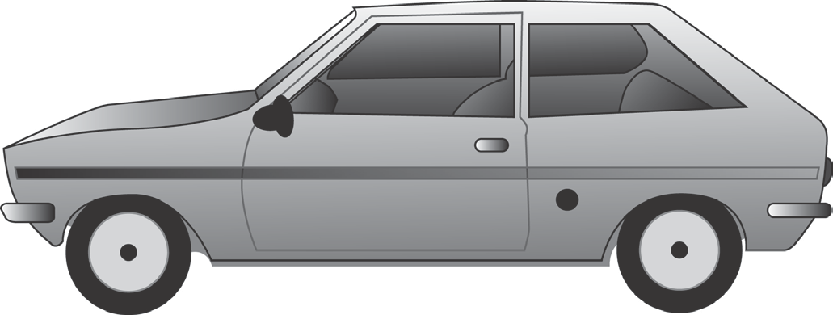

**Question 24-25**