NAVIGATION GUIDELINES FOR THE MONITORING, EVALUATION, RESEARCH, LEARNING AND ADAPTING COURSE Monitoring, Evaluation, Research, Learning and Adapting | RTI https://www.rti.org/monitoring-evaluation-research-learning-and-adapting
Here are some basic instructions for navigating this course (on a computer within the web browser). Although the course will work from the browser on a mobile device, some functionality may not be available or functions differently for mobile devices; for example, the ‘mouseover’ feature, used often in this course, would be a ‘long touch’.

Starting the course
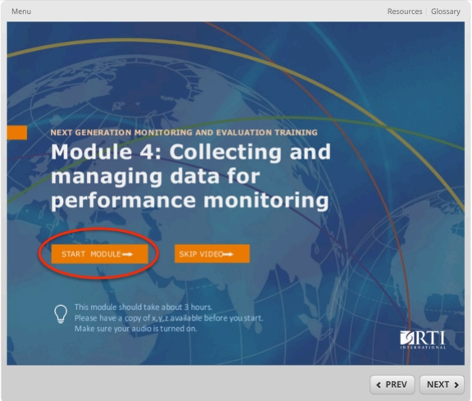
If this is your first time accessing the course, please start by clicking on “Start Module”. If you are coming back to the course for a second time, you can skip the video (if there is one), or use the “Menu” to navigate directly to a screen in the course.

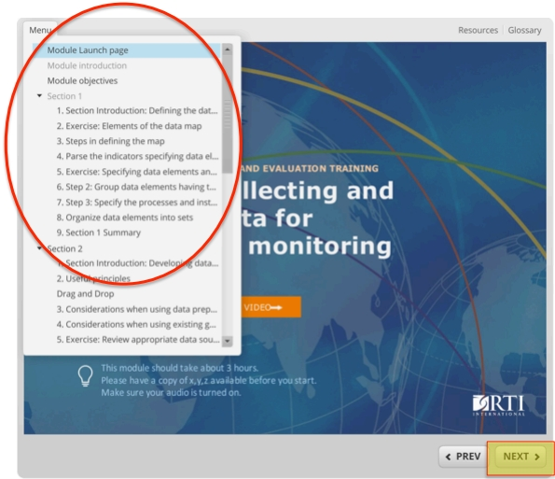
Clicking on “Menu” will expand the table of contents and allow you to jump anywhere in the course by clicking on the section or slide name.

The entire course is made up of a series of screens, similar to “slides” in a presentation. In most cases you should use the “next” button (see above highlighted in yellow) to advance from one slide to the next.

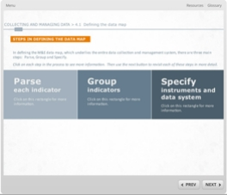
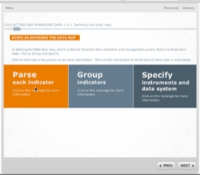
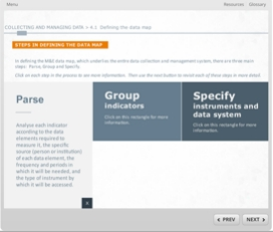
Within screens, there is often additional navigation possible, particularly tabs that expand to show more content, or items with a definition that shows when you place your mouse over the indicated area. Pay attention to instructions written in italic text.
Examples of tab interactions:
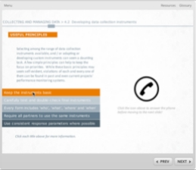
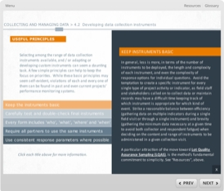
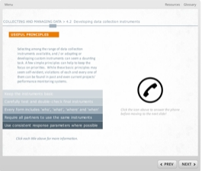
Original screen Mouse hover Mouse click

Original screen Mouse hover Mouse click

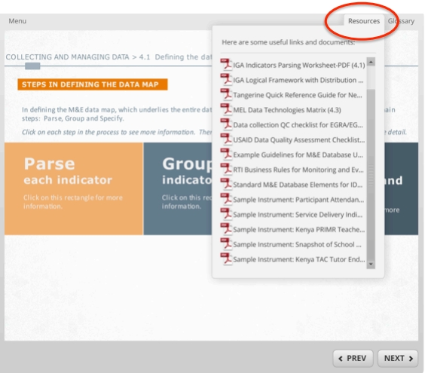
You can find reference documents referred to in the module by clicking on the “Resources” tab in the top right-hand corner and definitions of key terms by clicking on the “Glossary”.

FOR QUESTIONS OR NAVIGATION HELP, PLEASE CONTACT SPOUEZ@RTI.ORG

